Test Case: tc001_SPX_Dev5_Crear_Requisicion_Spot_Tipo_Cobro_CC
Step 1 - Enter username and password and click to button Enter : Credentials Entered
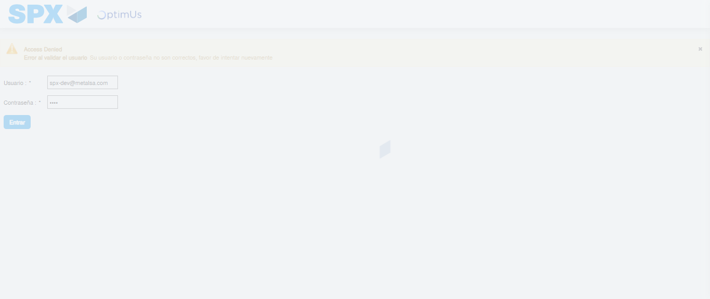Image file-name: QC_Testing-tc001_SPX_Dev5_Crear_Requisicion_Spot_Tipo_Cobro_CC-1788298010458

Step 2 - Select to UEN and Access to Spot Buy Requisitions : UEN Correctly selected and Correct access
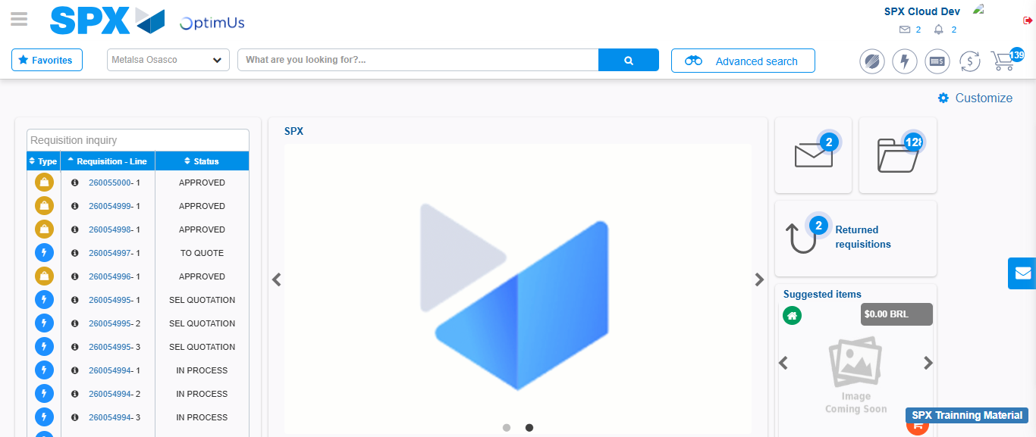Image file-name: QC_Testing-tc001_SPX_Dev5_Crear_Requisicion_Spot_Tipo_Cobro_CC-1788298036296

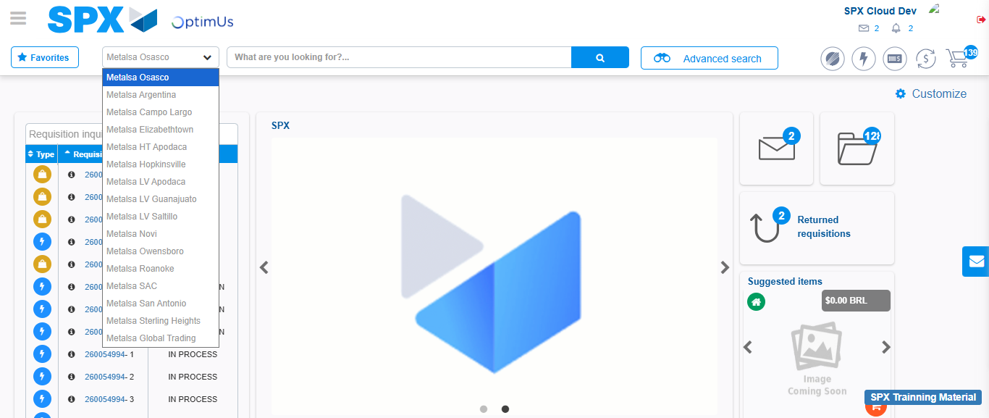Image file-name: QC_Testing-tc001_SPX_Dev5_Crear_Requisicion_Spot_Tipo_Cobro_CC-1788298036930

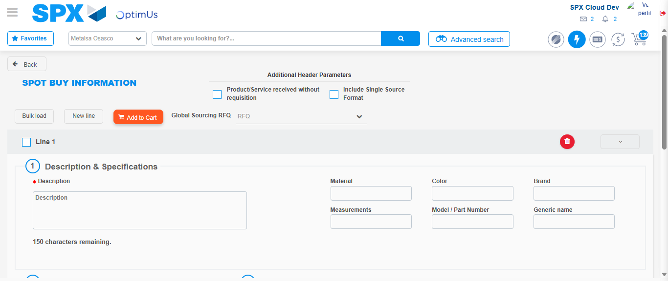Image file-name: QC_Testing-tc001_SPX_Dev5_Crear_Requisicion_Spot_Tipo_Cobro_CC-1788298054354

Step 3 - Data Capture Spot Buy Requisition : Data captured correctly
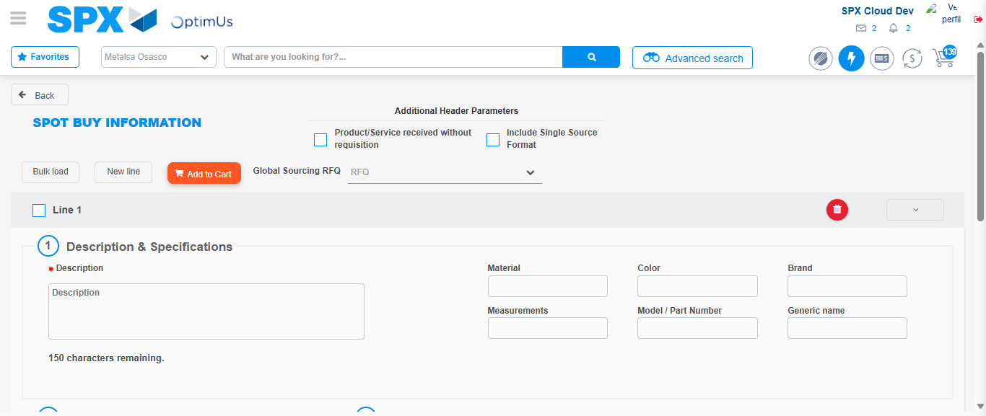Image file-name: QC_Testing-tc001_SPX_Dev5_Crear_Requisicion_Spot_Tipo_Cobro_CC-1788298054624

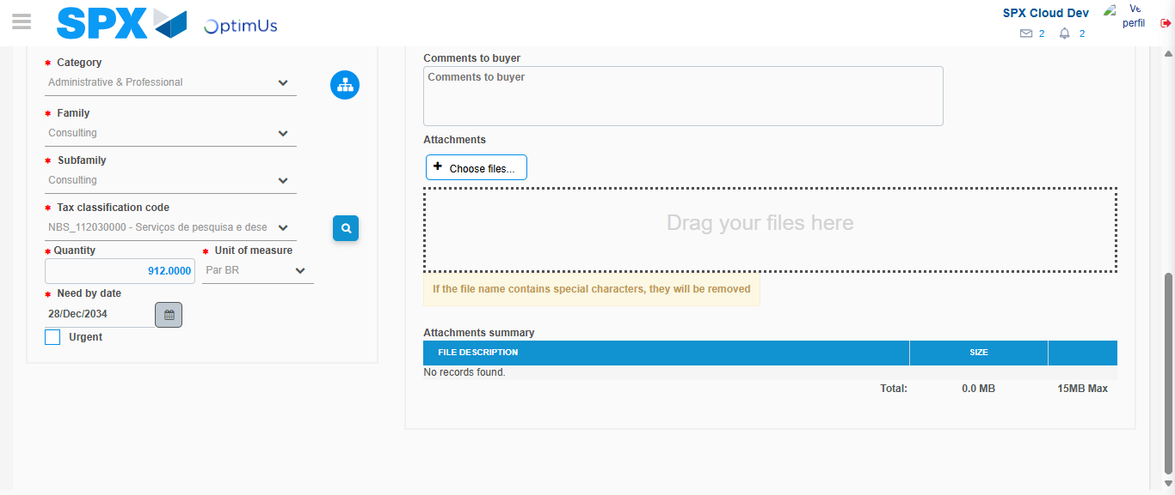Image file-name: QC_Testing-tc001_SPX_Dev5_Crear_Requisicion_Spot_Tipo_Cobro_CC-1788298069553

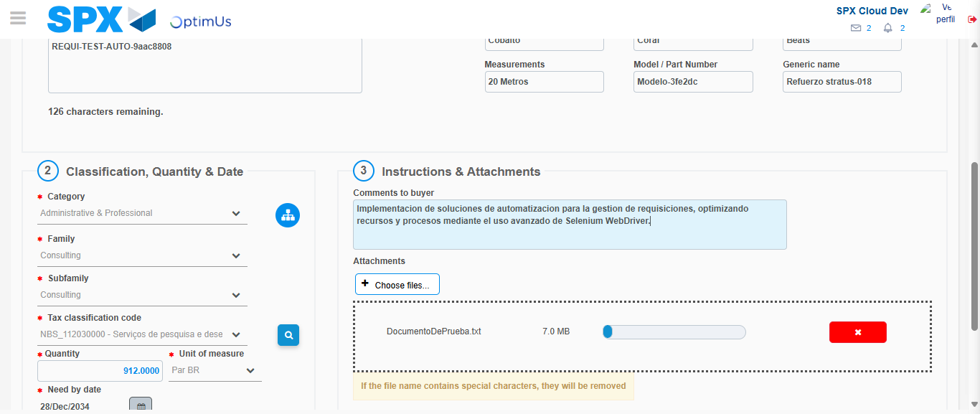Image file-name: QC_Testing-tc001_SPX_Dev5_Crear_Requisicion_Spot_Tipo_Cobro_CC-1788298070370

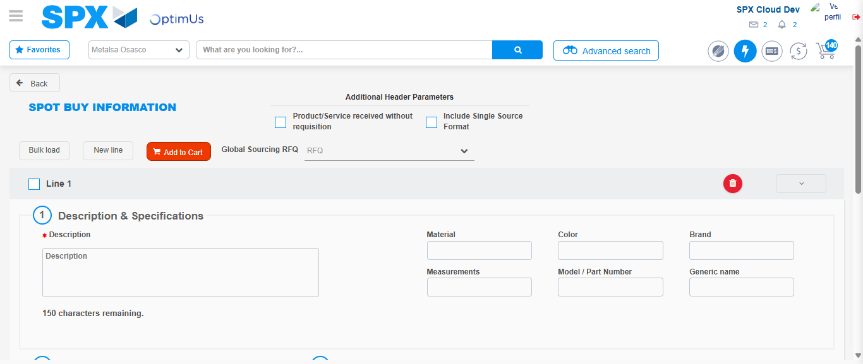Image file-name: QC_Testing-tc001_SPX_Dev5_Crear_Requisicion_Spot_Tipo_Cobro_CC-1788298086663

Step 7 - Return to Main Page SPX : Return to Main Page SPX
Image file-name: QC_Testing-tc001_SPX_Dev5_Crear_Requisicion_Spot_Tipo_Cobro_CC-1788298036296

Image file-name: QC_Testing-tc001_SPX_Dev5_Crear_Requisicion_Spot_Tipo_Cobro_CC-1788298036930

Image file-name: QC_Testing-tc001_SPX_Dev5_Crear_Requisicion_Spot_Tipo_Cobro_CC-1788298054354

Image file-name: QC_Testing-tc001_SPX_Dev5_Crear_Requisicion_Spot_Tipo_Cobro_CC-1788298088920

Image file-name: QC_Testing-tc001_SPX_Dev5_Crear_Requisicion_Spot_Tipo_Cobro_CC-1788298089075

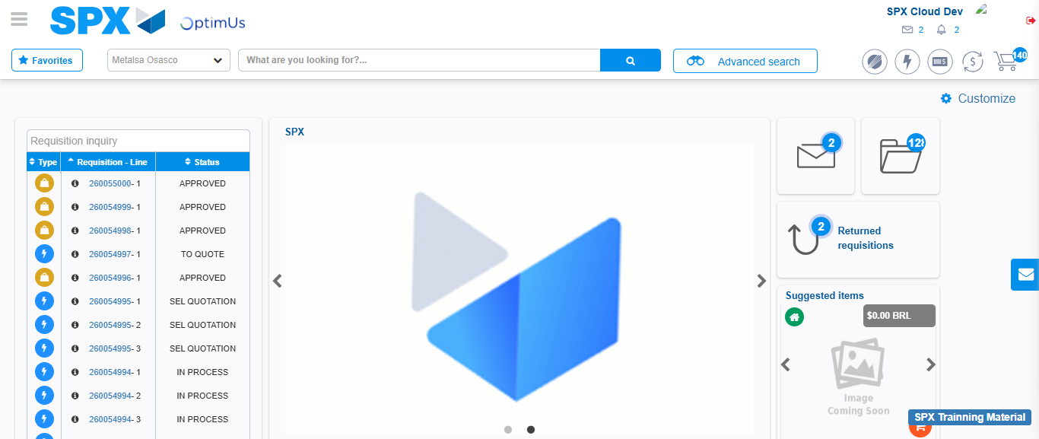Image file-name: QC_Testing-tc001_SPX_Dev5_Crear_Requisicion_Spot_Tipo_Cobro_CC-1788298110391

Step 8 - Log Out : Log Out SPX
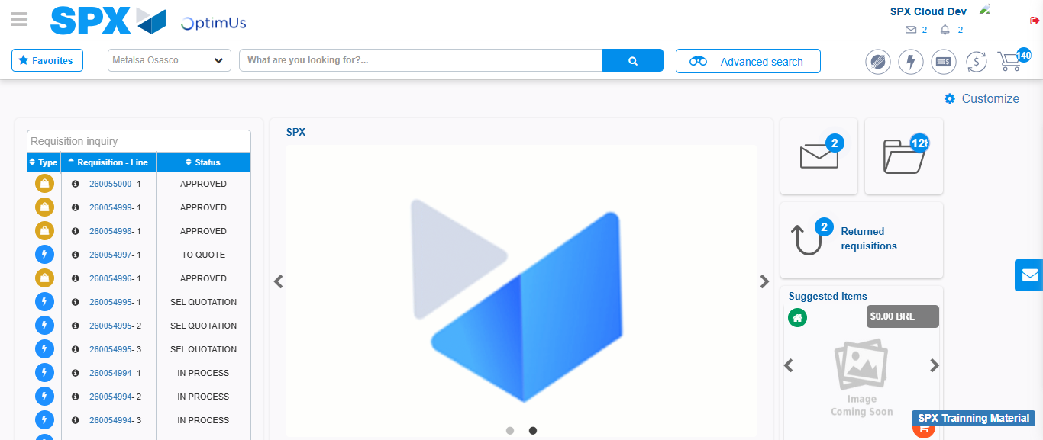Image file-name: QC_Testing-tc001_SPX_Dev5_Crear_Requisicion_Spot_Tipo_Cobro_CC-1788298110745

